Review/Re-teaching Packet: Forms of Government Name:____________________

Part 1: The purposes of Government

- What are the four purposes of Government?

- The Preamble to the Constitution (Our nation’s document that describes our government) explains the purposes of our government. Explain what each underlined phrase means:

"We the people of the United States, in order to | form a more perfect union | establish Justice | insure domestic Tranquility | provide for the common defense | promote the general welfare | and secure the blessings of liberty | to ourselves and our posterity, do ordain and establish this Constitution for the United States of America."

Part 2: Forms of Government
- What is a unitary form of government?
- What is a confederate form of government?
- What is a federal form of government?
- What are the advantages and disadvantages of unitary, confederate, and federal governments?
- The United States is a Federal government that has three distinct levels that share power. What are these three levels?
Democratic government | A form of government in which political control is exercised by all people, either directly or through their elected representatives.
Direct Democracy | Direct democracy allows people to make decisions by voting on issues individually.
Representative Democracy | Representative democracy allows people to elect individuals and give them the responsibility and power to make decisions about laws and how the government will operate.
Separation of Powers | The division of governmental power among several institutions that must cooperate in decision-making.
Parliamentary Democracy | A form of government which gives governmental authority to a legislature or parliament which in turn selects the executive from among its own members.
Presidential Democracy | A form of government in which the executive and legislative branches are separate, independent, and co-equal.
Authoritarian Government | A form of government in which those in power hold absolute and unchangeable authority over the people.
Democracy | A form of government in which political control is exercised by all people, either directly or through their elected representatives.
Monarchy | Autocracy in which a king,, queen, or emperor exercises supreme powers of government.
Oligarchy | A form of government in which small, usually self-appointed elite hold the power to rule.
Dictatorship | A form of government in which the leader has absolute power and authority.
Totalitarian | A government that exercises dictatorial (authoritarian) power over nearly every aspect of human dignity.
Majority Rule | A principle of democracy that asserts that the greater number of citizens in any political unit should select officials and determine policies.
Absolute Power | Being governed by a ruler without any limits or boundaries.

Part 3: Limited vs. Unlimited Governments

Limited Government: A government that is regulated so that it cannot take away the rights of its people.
Unlimited Government: A government with total power, including the power to take away the rights of its citizens.

Types of Authoritarian (Unlimited) Governments
Dictatorships have a single leader. Unlike monarchies, dictators usually come to power after a struggle for power. This struggle may be violent or may occur among a small group of leaders, from which a leader will emerge. Dictators have unlimited power to lead their country.  Governments under a dictator may have elections but the elections typically offer only one candidate or there are problems with the election process. This form of rule is marked by unlimited exercise of power. | 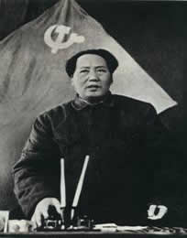  Mao Zedong (Tse-tung),  Leader of Communist China (1949)  Source: http://www.marxists.org/reference/archive/mao/images/1949-plenary.jpg
Oligarchies have a small group of people who lead and make decisions based on their own interest rather than the common good. The small group may come to power due to wealth or military strength. "Oligarchs may be military leaders, political party leaders, wealthy business owners or any other small group that gains control. Some Latin American countries have a long tradition of rule by military oligarchies."  Citation:SIRS database: http://sks.sirs.com/  In Guatemala, "between 1954 and 1986 a series of military, and one civilian (but de facto military), governments ruled."  Citation: http://www.db.idpproject.org  In oligarchies, one individual, a figurehead, may officially lead the country, but political power and decision making is in the hands of the group. | 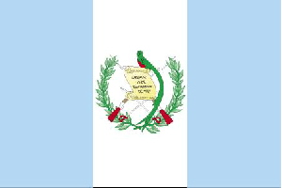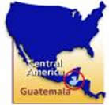  Source: www.fhi.net/images/ voc/guatemala-map.gif
In totalitarian governments, all aspects of human activity is controlled by the government. These governments have total control over the economy, the political decisions, and the social aspects of the nation. In countries with totalitarian governments, the people have no power to limit the authority of the government. Secret police use terror to control the people and the media, education and all forms of culture (music, literature, art) are regulated.  Historically, leaders such as Adolf Hitler (Germany, 1933-1945) and Josef Stalin (Soviet Union, 1924-1953) are examples of totalitarian leaders. | 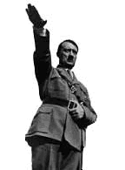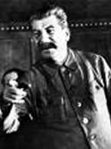

Characteristics of Limited Governments
“The basis of a democracy is liberty” Aristotle
A democracy is a government in which there are limits on the power of the government and its officials. Democratic governments are also called limited governments.
Characteristics of limited governments include:
- majority rule while protecting the rights of minorities
- protection of individual rights and liberties
- equality of opportunity
- consent of the governed
In limited governments, the government and its officials get power and authority from the people. Elections provide citizens with the opportunity to choose from a number of candidates for each office.
A written constitution sets up governmental rules and procedures. The rule of law guarantees that all citizens must obey the same laws. This means that a government official and a private citizen should not be treated differently if accused of a crime.
However, not all governments with constitutions are democracies. Nations such as China and North Korea have constitutions which limit the power of the government but do not protect the rights of citizens in the manner guaranteed by this written set of rules.

Closing Activity: BCR

Read the information below then use it to answer the BRIEF CONSTRUCTED RESPONSE that follows.
Niccolo Machiavelli, an Italian political theorist, concluded in his book The Prince that effective rulers use any means, moral or immoral to maintain law and order.
.
  - Would Machiavelli be in favor of a limited or unlimited form of government? Explain.
  - Do you agree with Machiavelli's opinion? Explain why or why not.
  - Include details and examples to support your answer.

